Our Sick and Shut-In
Iva Miles
Delores Prentice
Carolyn Smith

Carroll L. Jones, Sr.
Marion Jones
Dea. Theophilus Jones
Phyllis Charity
Stewart Greene, Sr.
Joyce Janes

The Bible encourages us to always pray for the sick, afflicted and one another. (James 5:13-16). Let’s remember to pray for and visit our sick and shut in.

Saint John Baptist Church Directory
www.STJBC.com
Email Address: SJ-BC@hotmail.com
Office: (804) 829-9196 / Fax: (804) 829-9198

Reverend Ellsworth Tait (Pastor) 852-7345
Reverend Vance Jones (Associate Pastor) 737-3388

Deacon Harold Charity (Chair of Deacons) 829-5146
Mrs. Tanya Thorpe (Chair of Trustees) 513-9950
Mrs. Donna L. Overby (Church Clerk) 928-4615
Mrs. LaToya Johnson Davis (Church Secretary) 873-7854
Mrs. Donna Lundy (John E. Jones Memorial Choir) 503-8239
Mrs. Pam Tait (Senior and Children’s Choirs) 674-1644
Mrs. Christina C. Jones (Director of Christian Education) 366-1312
Deacon Thomas E. Jones, III (Sunday School Superintendent) 829-5341

Sermon Title: “What’s Your Purpose?”
Scripture: Romans 8:28-31
Points to Remember:
___________________________________________________________________________________________________________________________________________________________________________________________________________________________________________________________________________________________________________________________________________________________________________________
Enter to Learn – Depart to Serve

Saint John Baptist Church
8131 Roxbury Road
Charles City, Virginia 23030

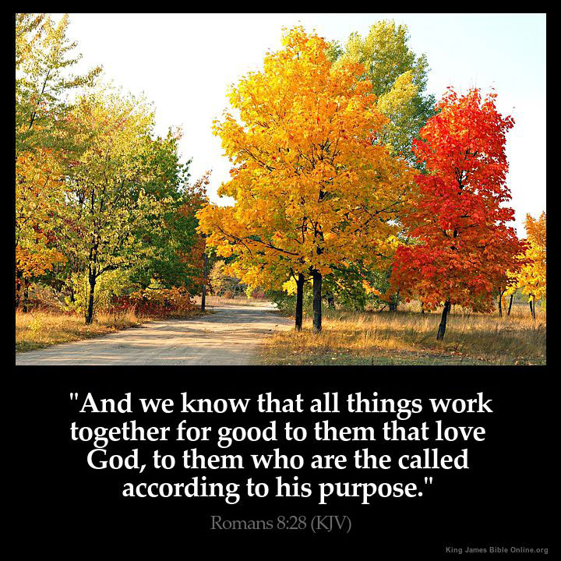

Sunday School at 9:45 a.m.
2019
Worship Service at 11:00 a.m.
Bible Study Wednesdays at 7:00 p.m.

Reverend Ellsworth Tait, Pastor
“We Bring People to Christ”

Sunday, January 19, 2020

Sunday, January 19, 2020 11:00 A. M.

THE ORDER OF SERVICE
Music by: Senior Choir
Worship Leader: Camryn Johnson

Worship through Praise
Call to Worship:
We bring people to Jesus Christ through the St. John Baptist Church family,
disciple them toward spiritual maturity; equip them for ministry, both in the
church and the world, that we may lift the name of Jesus in the sanctuary,
Charles City, New Kent, James City, Varina, Greater Richmond and the utmost
corners of the Earth.
Worship Leader: “WE BRING PEOPLE TO CHRIST”
Opening Selection: “Let The People Rejoice”
Morning Prayer: Worship Leader
Choral Chant: “Come Here Jesus” #439
Hymn of Praise: “I’m So Glad” #238

Worship through Fellowship
Acknowledgment of Visitors: Worship Leader
Announcements: Church Clerk
Baby Dedication: Little Miss Madison Lanae Charity Rev. Ellsworth Tait
A Black History Moment: A Tribute To Dr. Martin Luther King, Jr.
Pastoral Remarks: Rev. Ellsworth Tait

Worship through Ministry
Offering Sentence: “The point is this: whoever sows sparingly will also reap
sparingly, and whoever sows bountifully will also reap bountifully.”
2 Corinthians 9:6
The Offering: Ushers
The Offering Prayer: Deacons
Doxology: #651

Worship through Evangelism
Scripture: “Romans 8:28-31” Kaiden Thomas
Reader: The Word of God for the People of God
Bible Trivia:

In Today’s Scripture:

What can we say is the view in all of this?

Bible Trivia from last week:

Why was the harvest blown away?

Answer: Because my Temple lies in ruins while every one of you is busy working on your own house.

All: Thanks Be to God
The Inspirational Song: “God Is Good”
God’s Preached Word: Rev. Ellsworth Tait
“What’s Your Purpose?”

Worship through Discipleship:
Invitation to Christian Discipleship: Rev. Ellsworth Tait
Hymn of Invitation: “Come Unto Jesus”
Prayer: Rev. Ellsworth Tait
Closing Hymn “Get Right With God”
Benediction: Rev. Ellsworth Tait

CHURCH & COMMUNITY ANNOUNCEMENTS

The Steering Committee would like to thank everyone who participated in and attended the Program Development Training.

All announcements are due to the Clerk’s Office the Wednesday prior to the date it is to be announced.

Join us for Bible Study on Wednesday, January 23, 2020 at 7p.m. We will be studying Deuteronomy 32.

Anyone interested in joining a praise team/choir, please see Tanya Thorpe.

The Missionary Kitchen will be held on Wednesday, January 22, 2020 at New Vine Baptist Church-11:30 am-2:00 pm.

Scholarship applications are available to those who did not apply last June/July. The application package due date has been extended to Sunday, January 26th. Please include the following: an acceptance letter or grades, class schedule and status of good standing.

January 20th – Martin Luther King, Jr. Day Observance – County Wide
Charles City High School – 11:00 a.m. Dr. Jonathan Bibbs, Keynote Speaker

January 26th – Men’s Fellowship Meeting – 8:00 a.m.

The family of Little Miss Madison invites the congregation to join them for a reception in honor of her dedication in the fellowship hall immediately after Worship Service.

The ABCOTS Area II Session will be held at Saint John Baptist Church on Saturday, February 1, 2020---8am-1pm

