Our Sick and Shut-In
Iva Miles
Delores Prentice
Carolyn Smith

Carroll L. Jones, Sr.
Marion Jones
Dea. Theophilus Jones
Phyllis Charity
Stewart Greene, Sr.
Joyce Janes

The Bible encourages us to always pray for the sick, afflicted and one another. (James 5:13-16). Let’s remember to pray for and visit our sick and shut in.

Saint John Baptist Church Directory
www.STJBC.com
Email Address: SJ-BC@hotmail.com
Office: (804) 829-9196 / Fax: (804) 829-9198

Reverend Ellsworth Tait (Pastor) 852-7345
Reverend Vance Jones (Associate Pastor) 737-3388

Deacon Harold Charity (Chair of Deacons) 829-5146
Mrs. Tanya Thorpe (Chair of Trustees) 513-9950
Mrs. Donna L. Overby (Church Clerk) 928-4615
Mrs. LaToya Johnson Davis (Church Secretary) 873-7854
Mrs. Donna Lundy (John E. Jones Memorial Choir) 503-8239
Mrs. Pam Tait (Senior and Children’s Choirs) 674-1644
Mrs. Christina C. Jones (Director of Christian Education) 366-1312
Deacon Thomas E. Jones, III (Sunday School Superintendent) 829-5341

Sermon Title: “When you Pray, Come Boldly!”
Scripture: Hebrews 4:14-16
Points to Remember:
___________________________________________________________________________________________________________________________________________________________________________________________________________________________________________________________________________________________________________________________________________________________________________________
Enter to Learn – Depart to Serve

Saint John Baptist Church
8131 Roxbury Road
Charles City, Virginia 23030

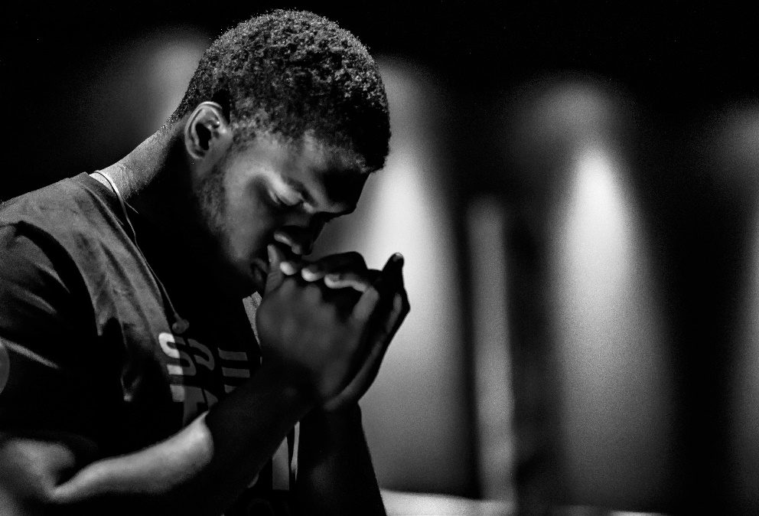
When You Pray,
Come Boldly!

Hebrews 4:14-16

Sunday School at 9:45 a.m.
2019
Worship Service at 11:00 a.m.
Bible Study Wednesdays at 7:00 p.m.

Reverend Ellsworth Tait, Pastor
“We Bring People to Christ”

Sunday, January 26, 2020

Sunday, January 26, 2020 11:00 A. M.

THE ORDER OF SERVICE
Music by: John E. Jones Choir
Worship Leader: Deacon Mona Adkins-Easley

Worship through Praise
Call to Worship:
We bring people to Jesus Christ through the St. John Baptist Church family,
disciple them toward spiritual maturity; equip them for ministry, both in the
church and the world, that we may lift the name of Jesus in the sanctuary,
Charles City, New Kent, James City, Varina, Greater Richmond and the utmost
corners of the Earth.
Worship Leader: “WE BRING PEOPLE TO CHRIST”
Opening Selection: “Every Praise”
Morning Prayer: Worship Leader
Choral Chant: “Jesus is Real to Me” #501
Hymn of Praise: “Over My Head” #169

Worship through Fellowship
Acknowledgment of Visitors: Worship Leader
Announcements: Church Clerk/Secretary
Pastoral Remarks: Rev. Ellsworth Tait

Worship through Ministry
Offering Sentence: “The point is this: whoever sows sparingly will also reap
sparingly, and whoever sows bountifully will also reap bountifully.”
2 Corinthians 9:6
The Offering: Ushers
The Offering Prayer: Deacons
Doxology: #651

Worship through Evangelism
Scripture: Hebrew 4:14-16 Deacons
Reader: The Word of God for the People of God
Bible Trivia:

In Today’s Scripture:

What will you find at God’s throne?

Bible Trivia from last week:

From last week’s Scripture,
What can we say is the view in all of this?

Answer: If God is for us, who can be against us?

All: Thanks Be to God
The Inspirational Song: “Praise is What I Do”
God’s Preached Word: Rev. Ellsworth Tait
“When You Pray, Come Boldly”

Worship through Discipleship:
Invitation to Christian Discipleship: Rev. Ellsworth Tait
Hymn of Invitation: “Center of My Joy” #491
Prayer: Rev. Ellsworth Tait
Closing Hymn “This is The Day”
Benediction: Rev. Ellsworth Tait

CHURCH & COMMUNITY ANNOUNCEMENTS

A Special Thank You goes out to all of the youth and young adults who participated in the Dr. Martin Luther King Tribute last Sunday.

Scholarship application packages are due TODAY for those who did not apply last June/July. Please include the following: an acceptance letter or grades, class schedule and status of good standing.

Anyone interested in joining a praise team/choir, please see Tanya Thorpe.

Join us for Bible Study on Wednesday at 7 p.m.
Study Topic: Genesis 18.

The ABCOTS Area II Session will be held at Saint John Baptist Church on Saturday, February 1, 2020---8am-1pm.

Next Sunday is Super Bowl Sunday, as well as the “Kick off” for Black History Month. Please wear your favorite football apparel.

Community Meetings to Discuss the Charles City Comprehensive Plan will be held at SJBC on: Tuesday, February 4th at 9 am
Thursday, February 6th at 7 pm
Please share this information with the others in the community.

All announcements are due to the Clerk’s Office the Wednesday prior to the date it is to be announced.

